Coastal defence quality survey
For each of the coastal defences mark a score for each of the categories in the rows. Use the letters of each coastal defence to record the score.
- Newbiggin sea wall (NSW)
- Newbiggin beach nourishment (NBN)
- Blyth sea wall (BSW)
- Blyth groynes (BG)
- Meggies Burn sand dune (MB)
- Natural dunes at Seaton Sluice (SS)_
 |  | 2 | 1 | 0 | -1 | -2
Effectiveness – how good is the scheme at reducing coastal erosion? Does it protect lives and property really well? | Effective |  |  |  |  |  | Ineffective
Cost – Look at the amount of engineering, maintenance and building materials. Look at the size of the defence. Does it look cheap to construct and maintain or not? | Cheap |  |  |  |  |  | Expensive
Aesthetics – how well does the scheme blend in with the natural or built environment? | Natural |  |  |  |  |  | Unnatural
Impact on residential/commercial/public buildings – is the coastal defence intrusive to other land uses? | Little impact |  |  |  |  |  | High impact
Multipurpose? Can the land at or near to the defence be used for other purposes? | Allows other land uses |  |  |  |  |  | Prevents other land uses
Ecological value – can other plants, animals and insects (etc.) survive together with the coastal defence? | High |  |  |  |  |  | Low ecological value
Impact on natural coastal processes – erosion and deposition | Low impact |  |  |  |  |  | High Impact
Total score
- Newbiggin (N)
- Newbiggin Beach Nourishment (NBN
- Blyth sea wall (BSW)
- Blyth groynes (BG)
- Meggies Burn sand dune (MB)
- Natural dunes at Seaton Sluice (SS)_

SEDIMENT SAMPLE
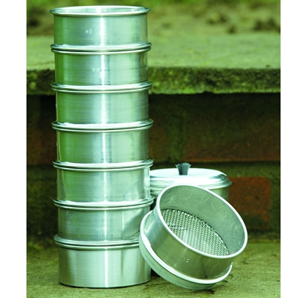
LOCATION OF SAMPLE
Method
- Weigh 1 kilogram of sediment
- Pass the sediment through the sieve
- Weigh the contents of each of the 10 sieves and record the results
Body Size | Aperture | Sample 1 | Sample 2 | Sample 3
10 | 2 mm
20 | 900 microns
30 | 600 microns
40 | 400 microns
60 | 250 microns
80 | 200 microns
100 | 140 microns
120 | 125 microns
250 | 63 microns

Data for profile DOWN the beach
LOCATION:
Top of beach | 1 | 2 | 3 | 4 | 5 | 6 | 7 | 8 | 9 | Sea
Distance between ranging poles
Gradient

Data for profiles across the groynes
Location:

SOUTH | 1 | 2 | 3 | 4 | 5 | 6 | 7 | 8 | 9 | NORTH
Distance between ranging poles
Gradient

Location:

SOUTH | 1 | 2 | 3 | 4 | 5 | 6 | 7 | 8 | 9 | NORTH
Distance between ranging poles
Gradient

Location:

SOUTH | 1 | 2 | 3 | 4 | 5 | 6 | 7 | 8 | 9 | NORTH
Distance between ranging poles
Gradient

